**ASSESSMENT BRIEF**



|  |  |  |  |  |  |
| --- | --- | --- | --- | --- | --- |
| **Title and Code of Minor Award: Graphical User Interface Programming 6N0736** | | |  | | |
| **Class: ACS61 & ACS62** | | |  | | |
| **Title: Skills Demo 1** | | |  | | |
| **Assessment No1. and Technique: Assignment** | | |  | **Weighting (30%):** | | |  | |
| **Issue Date: 02/11/2021** | | |  | **Extended Submission *Date:* ACS6 19/12/2021** | | |  | |
| **Feedback Date: 22/01/2022** | **Teachers** | Sonya Fay & Sean Ridge: | | |  | | |

|  |
| --- |
| **Learning Outcomes: 1,2,4,5,6,7,9 10** |



|  |  |
| --- | --- |
| **Learner Name (Print):** | Eoin Fitzsimons |
| **I confirm that I have kept a copy of my work and that this is my own original work.** | |
| **Signature:** |  |

|  |  |  |
| --- | --- | --- |
| **Assessment Criteria** | **Max. Mark** | **Learner Mark** |
| Program documentation etc | 6 |  |
| Application Interface | 8 |  |
| Quality of application… | 12 |  |
| Testing of application | 4 |  |
| **Subtotal** | **30** |  |
| ***Marks deducted for Late Submission:*** | |  |
| **Total Mark:** Mark is **provisional** and subject to change by the external authenticator. | |  |

|  |
| --- |
| **Teacher Feedback: It is the learner’s responsibility to be in class when feedback is being given.** |
| **Strengths:** |
| **Areas for improvement:** |

**Learner Tasks and presentation guidelines. 30%:**

You are required to develop a college record management application in Visual Basic 2008 to process assessments results in QQI Level 5 Object Oriented Programming.

The program will record and process marks for each assessment for this module for a small class group. The marks for these assessments are as follows.

**Assessment Name** **Marks** **Value**

Assignment 1 20 20%

Assignment 2 20 20%

Assignment 3 30 30%

Examination 30 30%

**Form 1.** A login screen will provide password access to two users, **(i)** **administrator** user with administrative rights to write records to file and read results data from **the same** text file that is to be named **results.dat** and **(ii)** a **guest** user who may only view records from this text file. Usernames will be selected from a **drop-down combo box**. The **password** should be **password** for test purposes. This **password** must be entered in the text property of the relevant text box and should not be **case sensitive**. **Users have 20 seconds to log on.**  This form must demonstrate the use of **animation** using at least 10 image controls.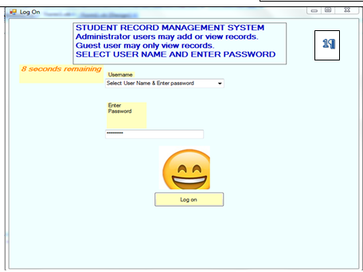

The login screen must provide feedback for correct and incorrect username/password combinations.

**Form 2.** The user will be presented with the menu options screen as indicated below. Include a label to set out in detail the rights and permissions available to administrator and guest users. 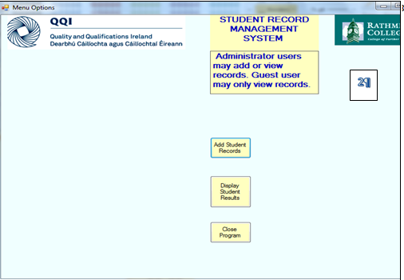

________________________________

**Form 3**.

The **Add Student Records form** will enable the administrator (but not guest user) to record each student’s, **student name** and results for **assignment 1** (>=1 AND <=20), **assignment 2** (>=1 AND <=20), Assignment**3** (>=1 AND <=30) and exam(>=1 AND <=30) for this module.

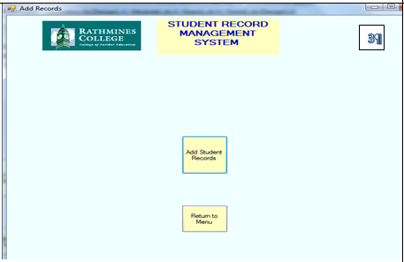

Include the Rathmines College logo on the form and a return to menu button.

The Add New Records button will be accessible only to Administrator. Input box controls will be used to capture Name, Assignment 1 mark, Assignment 2 mark, Assignment 3 mark and the Examination mark. The program will capture the following test data.

|  |  |  |  |  |
| --- | --- | --- | --- | --- |
| Name | Assignment 1 Mark (20) | Assignment 2 Mark (20) | Assignment 3 Mark (30) | Examination Mark (30) |
| Andy Murphy | 19 | 20 | 30 | 30 |
| Boris Johnson | 10 | 15 | 30 | 24 |
| Joe Boden | 10 | 20 | 10 | 20 |
| Mary O’ Rourke | 15 | 15 | 15 | 15 |
| Sandra Murphy | 10 | 10 | 10 | 10 |
| Robert Kearney | 19 | 20 | 30 | 30 |

**CAO points are awarded for QQI grades are as follows**

**Marks** **Grade** **CAO Points**

**<50 U**nsuccessful **0**

**>=50 AND < 65 P**ass **16.67**

**>=65 AND <80 M**erit **33.33**

**>=80 D**istinction **50**

The **Add Student Records screen** will only accept valid data. It will calculate total mark%, QQI grade and the CAO points for each student and write all of the following data to the text file e.g.

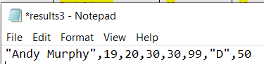*

This program which validates user passwords also validates each assignment and exam mark as follows.

**Assignment 1 & 2** marks must be **>= 1 and <=20. Assignment 3 & Exam** marks must be **>=1 and <=30.**

Remember your program will write a record to include student name, the results fields above and also the total-mark, calculated Grade (D, M, P or U) and CAO point.

**Form 4.** Display Student Report.

This form displays an exam results report (as illustrated) with the column headings below.

The report will **identify the student or the students** with the best overall marks, the student with the lowest mark and the average mark. Add a **help button** to this form that provides specific information about the input data, the manner in which it is processed and the access rights for both users. 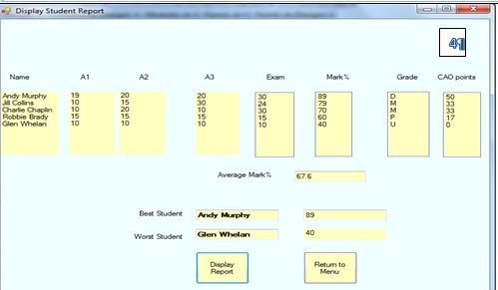

This report must display the student names and data on page 3.

**5.** Write a short report describing how you developed this record management system from design to tested application as follows.

Prototyping

Eoin Fitzsimons

# Why do we prototype?

We prototype so we can go back to versions we are happy with the path we take is not satisfactory. It is an efficient way of being able to go back to go forwards in another, better direction.

It is also a tool for planning, you may consider a graphical version of what you want the result to look like without any functional code a prototype.

# Prototype Images

(ii) Marks are allocated for simplicity and consistency of design. Include three elements of design enhancement to each form using **consistent** background colour, text colour, text formatting, text size etc. Good screen design also includes providing adequate user information regarding what the screen is intended to do, explaining user rights, and provides for **error trapping and** context sensitive error messages. Include the Rathmines College logo and the QQI logo (appropriately sized) on the menu form/screen.

(iii) Write a short paragraph regarding testing the application to include your test data, expected results and actual results

Originally, I just entered the grades and Cao points through the system, I decided this was not an ideal solution and I felt the programme should calculate so wrote a little bit of my own maths code for what the grade and points should be based off all marks. I had issues getting this working as I was not sure how the syntax for number ranges worked. I was unable to add an upper or lower limit for the marks, I’d assumed if I were to give it a range I could have it where the input wasn’t accepted but it didn’t work unfortunately so I rolled back a prototype to where before I tried adding that.

6. Marks are allocated for the following.

* Using the naming conventions for forms and controls.
* Start-up position for each form should be CenterScreen.
* All forms should be the same size.
* Define a keyboard access key for each Command control.

7. Save the project and the report document in a folder called your name GUI A1 2021 and submit on Rathmines College MOODLE by midnight on Sunday 19th December 2021